**Name:JOBIN T J**

**Roll No: 7**

**Batch: BATCH B**

**Date: 08-04-2022**

**ADVANCED DBMS LAB**

**Experiment No.: 1**

**Aim**

To study various DDL commands – CREATE, INSERT

**QUESTION**

Create the following table emp

CREATE TABLE emp(EMPNO INT PRIMARY KEY, ENAME CHAR(10), HIREDATE DATE, SALARY INT ,COMMISSION INT);

**PROCEDURE**

1.Create table emp and insert values

CREATE TABLE emp(EMPNO INT PRIMARY KEY, ENAME CHAR(10), HIREDATE

DATE, SALARY INT ,COMMISSION INT);

INSERT INTO emp(EMPNO,ENAME,HIREDATE,SALARY) VALUES(101,'Ramesh',

'1980-01-17',5000);

INSERT INTO emp(EMPNO,ENAME,HIREDATE,SALARY,COMMISSION) VALUES(102,'Ajay','1985-07-05',5000,500);

INSERT INTO emp(EMPNO,ENAME,HIREDATE,SALARY) VALUES(103,'Ravi',

'1981-08-12',1500);

INSERT INTO emp(EMPNO,ENAME,HIREDATE,SALARY,COMMISSION) VALUES(104,'Nikesh','1983-03-03',300,700);

INSERT INTO emp(EMPNO,ENAME,HIREDATE,SALARY) VALUES(105,'Ravi',

'1985-07-05',3000);

2. ALTER TABLE emp ADD SAL INT

3. ALTER TABLE emp DROP COLUMN sal;

4.ALTER TABLE emp MODIFY ENAME VARCHAR(15);

5. RENAME TABLE emp TO emp1;

6. TRUNCATE TABLE emp1;

7. DESC emp1;

8. DROP TABLE emp1;

**Output Screenshot**

1. **EMP table**

**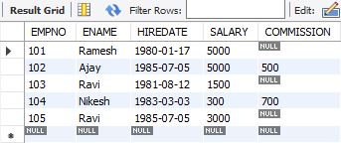**



**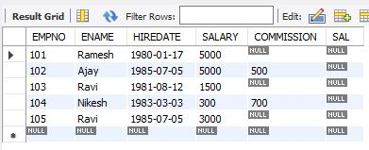**

**3.**

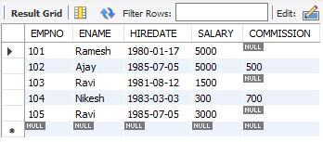

**4.**

**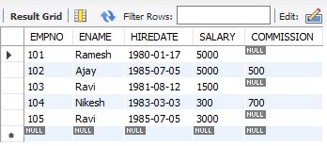**

**5.**

**D:\vineeth(dbms)\EXP3_OP\5(a).JPG**

**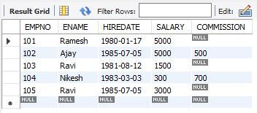**

**6.**

**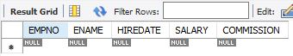**

**7.**

**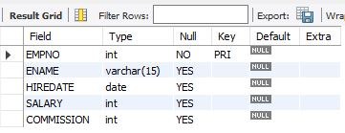**

**8.**

**D:\vineeth(dbms)\EXP3_OP\8.JPG**

**9.**

****